**CI Process in Automation with Robot**

**Step1**: Developer Checks in the Code in SVN

**Step2**: Dev Build on Jenkins Gets Triggered (Build, Compile and Deploy the applications)

**Step3**: Once the Dev build Get Completed, Automatically Triggers the Jobs created for automation script execution

1. Automation build will run the Pybot command with the location of the Scripts

**Step 4**: Mail is triggered with the execution results of automation Scripts

Source Code Management Configuration

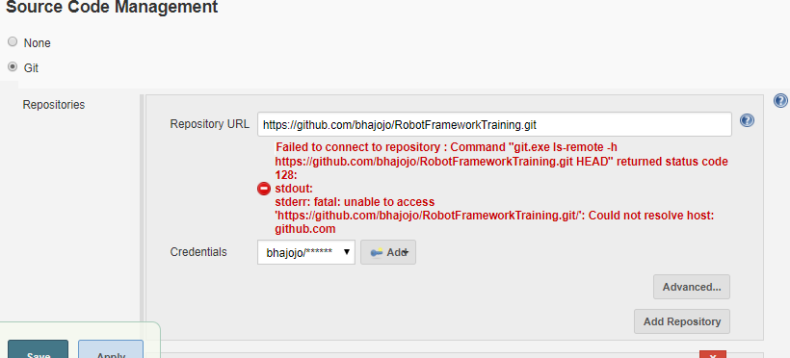

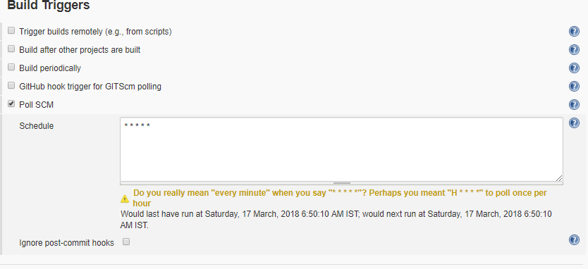

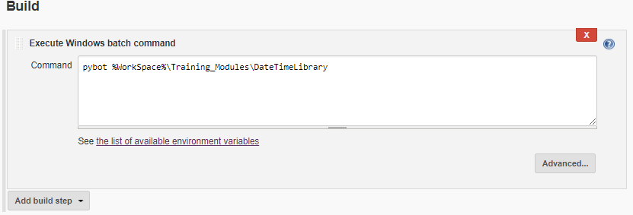

If you want your project to be dependent on other project. Select it in post build action

